The Islamia University of Bahawalpur
Department of Information Technology


Software Design Document (SDD)
for
<PESTICIDE MANAGEMENT SYSTEM>
Version 1.0

By
Alina Binish
F24BINFT7M04003
Session: Fall 2024 – 2026
SUPERVISOR:
Ma’am Kainat
Bachelor of Science in Information Technology

Table of Contents
1. Introduction 3
1.1 Purpose 3
1.2 Scope 3
2. Architectural Overview 4
2.1 Overview 4
2.2 High-Level Components 4
3. Detailed Design 6
3.1 User Interface (UI) Module 6
3.1.1 Overview 6
3.1.2 Components 6
3.2 Pesticide Inventory Module 6
3.2.1 Overview 6
3.2.2 Components 6
3.3 Application Scheduling Module 7
3.3.1 Overview 7
3.3.2 Components 7
4. Design Patterns and Technologies 7
4.1 Design Patterns 8
4.2 Technologies 8
5. Interaction Diagrams 9
5.1 Sequence Diagrams 9
6. Data Flow Diagrams 11
6.1 Context Diagram 11
6.2 Data Flow Diagrams 12
7. User Interface Wireframes 13
8. Security Considerations 14
9. Conclusion 16

1. Introduction
1.1 Purpose
The primary purpose of the Pesticide Shop Management System is to streamline and optimize the various facets of pesticide shop operations. This includes inventory management to ensure timely availability of products, sales and billing processes to facilitate smooth transactions, and compliance with industry regulations to uphold safety standards.
The system aims to empower pesticide shop owners and operators with a robust toolset that enhances operational efficiency, reduces manual errors, and provides valuable insights for informed decision-making. By centralizing critical processes, the system contributes to a more organized, responsive, and customer-centric approach to pesticide shop management.
1.2 Scope:
The scope of the Pesticide Shop Management System encompasses the end-to-end processes involved in running a pesticide shop efficiently. This includes but is not limited to:
- Inventory Control:
Tracking and managing pesticide stock levels.
Implementing automated reorder points to prevent stockouts.
Streamlining the storage and retrieval of inventory data.
- Sales and Billing:
Facilitating quick and accurate sales transactions.
Generating invoices, receipts, and reports seamlessly.
Providing a user-friendly interface for sales representatives.
- Product Catalog Management:
Maintaining a comprehensive catalog of pesticide products.
Enabling easy addition, modification, and removal of products.
Including detailed product information for accurate record-keeping.
- Customer Relationship Management (CRM):
Building and managing customer profiles.
Facilitating personalized interactions and targeted marketing efforts.
Improving customer service through efficient order processing.
- Regulatory Compliance:
Ensuring adherence to industry regulations and safety standards.
Providing features for proper handling, storage, and sale of pesticides.
Generating reports to demonstrate compliance during inspections.
- Reporting and Analytics:
Offering robust reporting tools for sales trends and product performance.
Providing analytics for data-driven decision-making.
Enhancing business intelligence through actionable insights.

2. Architectural Overview
1. System Architecture:
- The system follows a client-server architecture.
- Client-side for user interfaces (web or desktop application).
- Server-side for business logic, database, and external integrations.
2. Client-Side:
- Web Interface (Optional)
  - HTML, CSS, JavaScript for browser-based access.
  - Responsive design for various screen sizes.
- Desktop Application (Optional)
  - GUI application for desktop users.
3. Server-Side:
- Web Server:
- Hosts the web application (if applicable).
- Manages user requests and responses.
- Application Server:
- Hosts the core application logic.
- Handles business processes like sales, inventory, and customer management.
- Database Server:
- Stores and retrieves data related to products, customers, transactions, etc.
- May use a relational database system (e.g., MySQL, PostgreSQL).
4. Communication:
- Client-Server Communication:
- Communication via HTTP/HTTPS protocols.
- Restful API for data exchange between the client and server.
- Database Communication:
- SQL queries for database interactions.
5. Security:
- User Authentication:
- Secure login mechanisms.
- Use of tokens or session management for user sessions.
- Data Security:
- Encryption for sensitive data during transmission
- Access controls and permissions for data protection.
6. Integration:
- External Systems:
- Integration with external systems for data exchange (e.g., supplier systems).
- APIs for connecting with other business tools.
7. Scalability:
- Horizontal Scaling:
- Ability to scale by adding more server instances.
- Load balancing for distributing incoming requests.
8. Performance Optimization:
- Caching:
- Implement caching mechanisms to improve response times.
- Database Indexing:
- Optimize database queries for efficiency.
9. Logging and Monitoring:
- Logging:
- Record system events and errors for debugging.
- Monitoring:
- Use monitoring tools to track system performance and health.
10. Deployment:
- Deployment Strategy:
- Define a strategy for deploying updates and releases.
- Use containerization (e.g., Docker) for consistent deployments.
11. Maintenance:
- Version Control:
- Implement version control for source code.
- Regular Updates:
- Plan for regular system updates and maintenance.
Conclusion:
The architectural overview provides a broad understanding of how the Pesticide Shop Management System is structured, from the client-side interface to the server-side logic and data storage. This high-level architecture serves as a foundation for more detailed design and implementation considerations.
3. Detailed Design
3.1 User Interface (UI) Module
3.1.1 Overview
The UI module focuses on presenting information to users and capturing their interactions.
3.1.2 Components
- Dashboard: Displays summary information on pesticide inventory, upcoming applications, and compliance status.
- Pesticide Inventory Management Interface: Allows users to add, update, and delete pesticides.
- Application Scheduling Interface: Facilitates the scheduling of pesticide applications.
- Reporting Dashboard: Displays reports on pesticide usage, effectiveness, and compliance.
3.2 Pesticide Inventory Module
3.2.1 Overview
This module manages the pesticide inventory and associated functionalities.
3.2.2 Components
- Pesticide Inventory Management: Implements functions for adding, updating, and deleting pesticides.
- Stock Tracking: Monitors real-time stock levels and adjusts quantities based on applications.
- Alert System: Notifies users when stock levels are low or when pesticides are approaching expiration dates.
3.3 Application Scheduling Module
3.3.1 Overview
The Application Scheduling Module facilitates the scheduling of pesticide applications.
3.3.2 Components
- Calendar Integration: Allows users to schedule pesticide applications on a calendar.
- Weather Integration: Retrieves weather forecasts to assist in optimal scheduling.
- Application Tracking: Monitors the status of scheduled applications.
(Continue with detailed design for other modules such as Reporting, Authentication and Authorization, and Database.)
4. Design Patterns and Technologies
Designing a pesticide shop management system involves considering various design patterns and technologies to ensure a robust, scalable, and maintainable solution. Here are some design patterns and technologies that you might find useful for developing such a system:
4.1. Design Patterns:
1. Model-View-Controller (MVC):
Separate the application into three interconnected components: Model (data and business logic), View (user interface), and Controller (handles user input and updates the model and view).
2.Repository Pattern:
Use a repository to separate the logic that retrieves the data from the underlying database, providing a clean and consistent interface for data access.
3.Observer Pattern:
Implement the observer pattern to notify and update relevant parts of the system when changes occur. This can be useful for managing inventory, sales, or other real-time updates.

4. Singleton Pattern:
Ensure that certain components, such as the database connection or configuration manager, are instantiated only once throughout the application.

5.Strategy Pattern:
Use the strategy pattern for managing different types of pesticides or products. This allows you to define a family of algorithms, encapsulate each one, and make them interchangeable.
6.Command Pattern:
Implement the command pattern to encapsulate a request as an object, allowing users to parameterize clients with different requests and queue or log requests.
7. State Pattern:
Use the state pattern to represent the different states of an order or transaction, such as "pending," "shipped," or "completed."
8.Decorator Pattern:
Apply the decorator pattern to add additional features or behaviors dynamically to products or orders without altering their structure.
4.2. Technologies:

1. Programming Language:
Choose a programming language that fits the development team's expertise and the project's requirements. Common choices include for frontend Html , Css and javascript and for backend php ,mysql

2. Web Framework:
If building a web-based system, consider using a web framework such as Django (Python), Spring Boot (Java), or ASP.NET Core (C#).

3. Database:
Use a relational database like MySQL, PostgreSQL, or Microsoft SQL Server for storing product details, sales data, and customer information.

4. Front-End Framework:
Employ a front-end framework like React, Angular, or Vue.js for building a responsive and interactive user interface.

5.RESTful API:
Design a RESTful API to facilitate communication between the front-end and back-end components. Use HTTP methods for CRUD operations (Create, Read, Update, Delete).

6. Authentication and Authorization:
Implement secure authentication and authorization mechanisms to protect sensitive data and functionalities. OAuth or JWT (JSON Web Tokens) can be considered.

7.Containerization:
Use containerization technologies like Docker to package the application and its dependencies into a standardized unit, ensuring consistency across different environments.

8.Version Control:
Utilize version control systems like Git to manage and track changes in the source code.

9.Automated Testing:
Implement automated testing using frameworks like JUnit, pytest, or NUnit to ensure the reliability of the application.

10.Continuous Integration and Deployment (CI/CD):
Set up CI/CD pipelines to automate the building, testing, and deployment processes, ensuring a smooth and efficient development workflow.

11.Logging and Monitoring:
Integrate logging and monitoring tools (e.g., ELK Stack, Prometheus, Grafana) to track application performance, detect issues, and facilitate troubleshooting.
Remember to adapt these choices based on the specific requirements, scale, and constraints of your pesticide shop management system.
5. Interaction Diagrams
5.1 Sequence Diagrams
Sequence diagrams illustrating the flow of interactions during pesticide inventory management, application scheduling, and reporting.
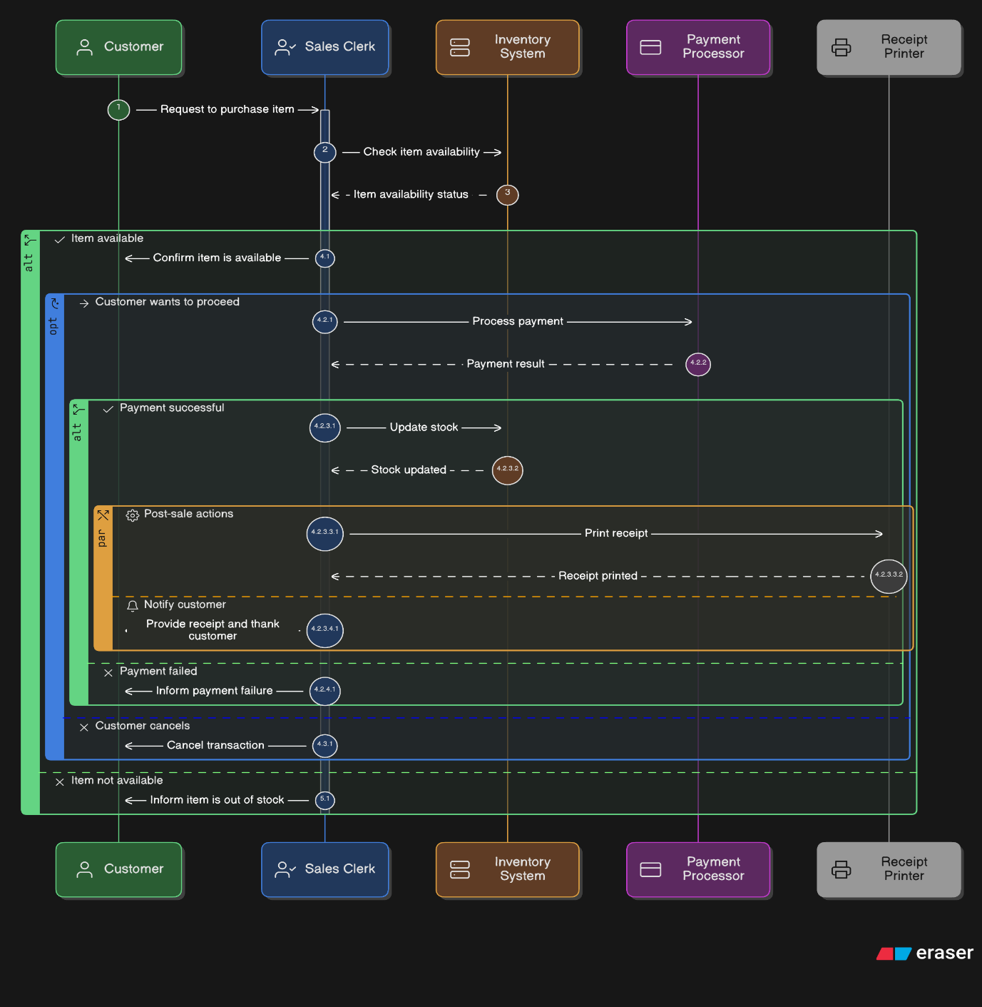
Certainly! Below is a textual representation of a sequence diagram for the "Process Sales" activity in the Pesticide Shop Management System:

Figure : Sequence diagram
Explanation:
1. Customer requests a sale: The customer initiates a sale by selecting products and indicating the intention to purchase.
2. Sales Clerk confirms the sale:The sales clerk confirms the sale, ensuring availability of products and verifying the customer's request.
3. Update Stock: The system updates the inventory by reducing the stock of the sold products.
4. Update Records: Simultaneously, the system updates customer records and transaction history.
Arrows indicate the flow of messages between the customer, sales clerk, and inventory system during the process of sales. This sequence diagram provides a high-level overview of the interactions involved in processing a sale in the Pesticide Shop Management System.
6. Data Flow Diagrams
6.1 Context Diagram
A context diagram illustrating the high-level interactions between the Pesticide Management System and external entities
Certainly! Below is a textual representation of a context diagram for the Pesticide Shop Management System:
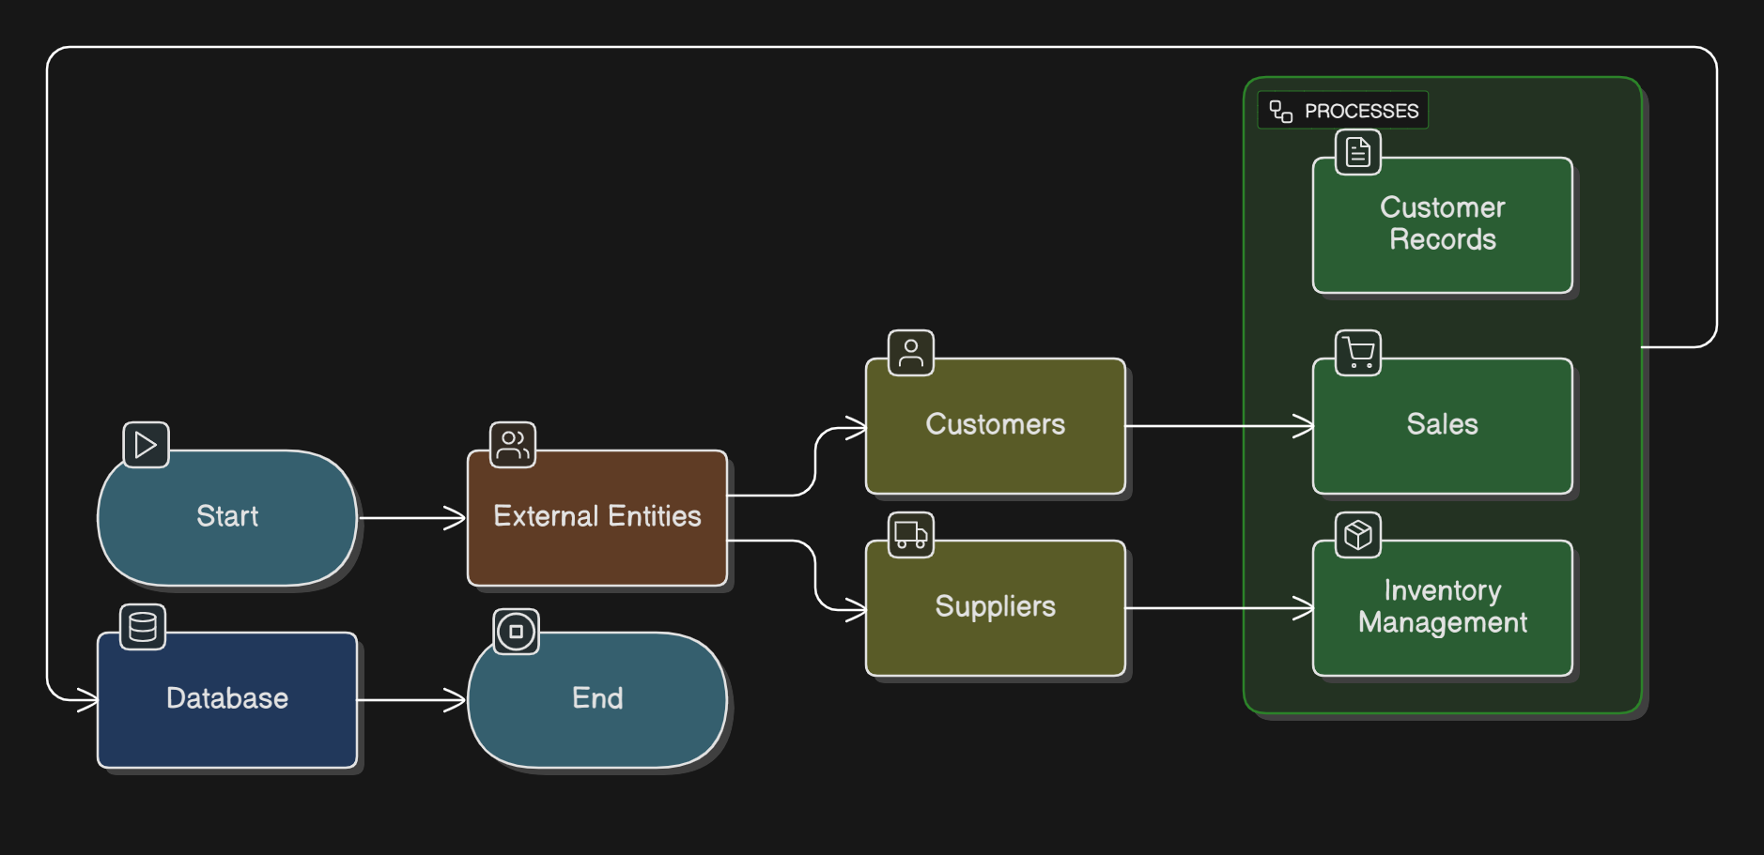
Figure: context diagram
Explanation:
Pesticide Shop Management System: Represents the entire system.
External Entities (Customers, Suppliers): Entities external to the system that interact with it.
Processes (Sales, Inventory, Customer Records): Core functionalities or processes within the system.
Data Store (Database): Represents the storage of data used by the system.
In this context diagram, arrows indicate the flow of data between the elements. The external entities interact with the system processes, which, in turn, utilize the data store to manage information. The context diagram provides a high-level view of the Pesticide Shop Management System and its interactions with the external environment.
6.2 Data Flow Diagrams
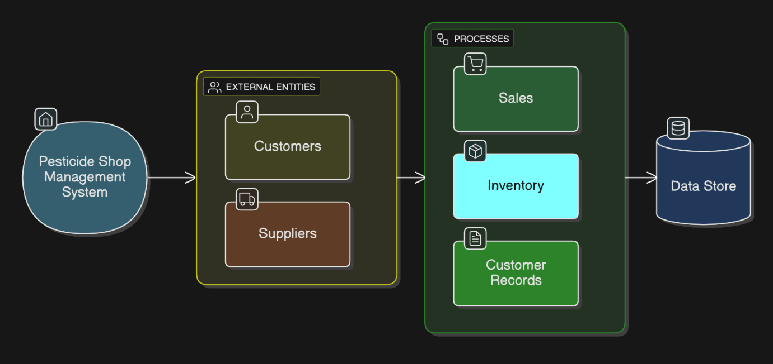
Detailed data flow diagrams for pesticide inventory management, application scheduling, and reporting.

Figure: data flow diagram

Explanation:
External Entities (Customers, Suppliers): Entities external to the system that interact with it.
Processes (Sales, Inventory, Customer Records): Core functionalities or processes within the system.
Data Store (Database): Represents the storage of data used by the system.
Arrows indicate the flow of data between elements. External entities interact with the system processes, which, in turn, utilize the data store to manage information. This DFD provides a high-level overview of the data flow within the Pesticide Shop Management System. Remember that in a more detailed DFD, you would typically have additional processes and data flows, each representing specific functionalities and interactions.
7. User Interface Wireframes
Wireframes for key interfaces, including pesticide inventory management, application scheduling, and reporting.
Below are textual representations of wireframes for two main screens of a Pesticide Shop Management System: the "Product Management" screen and the "Sales" screen.
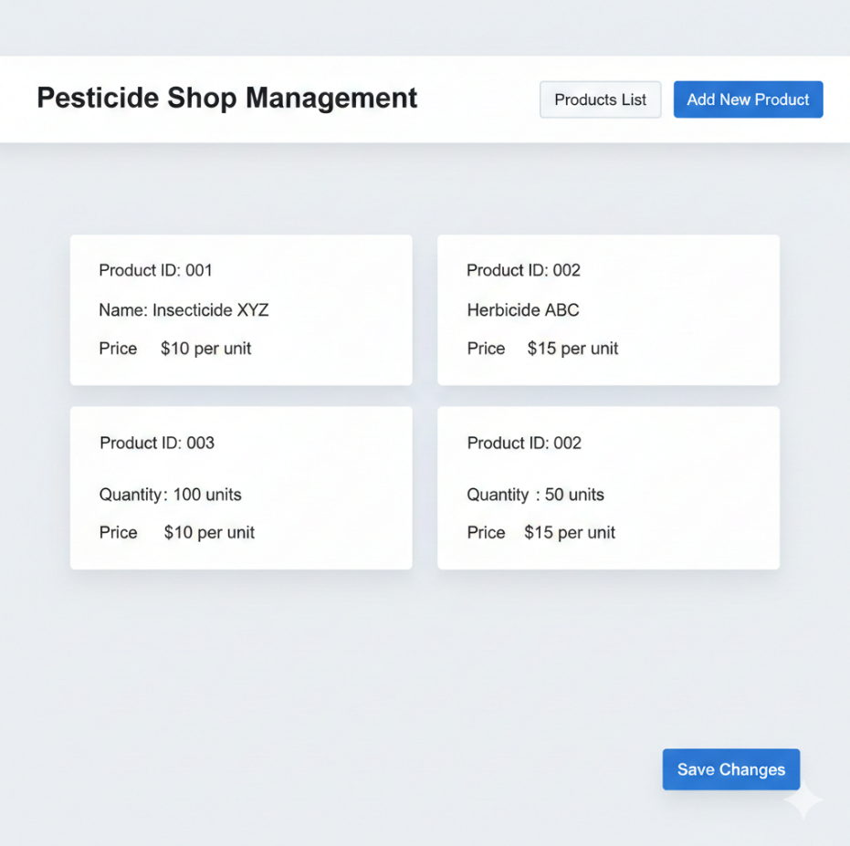
Figure: product management
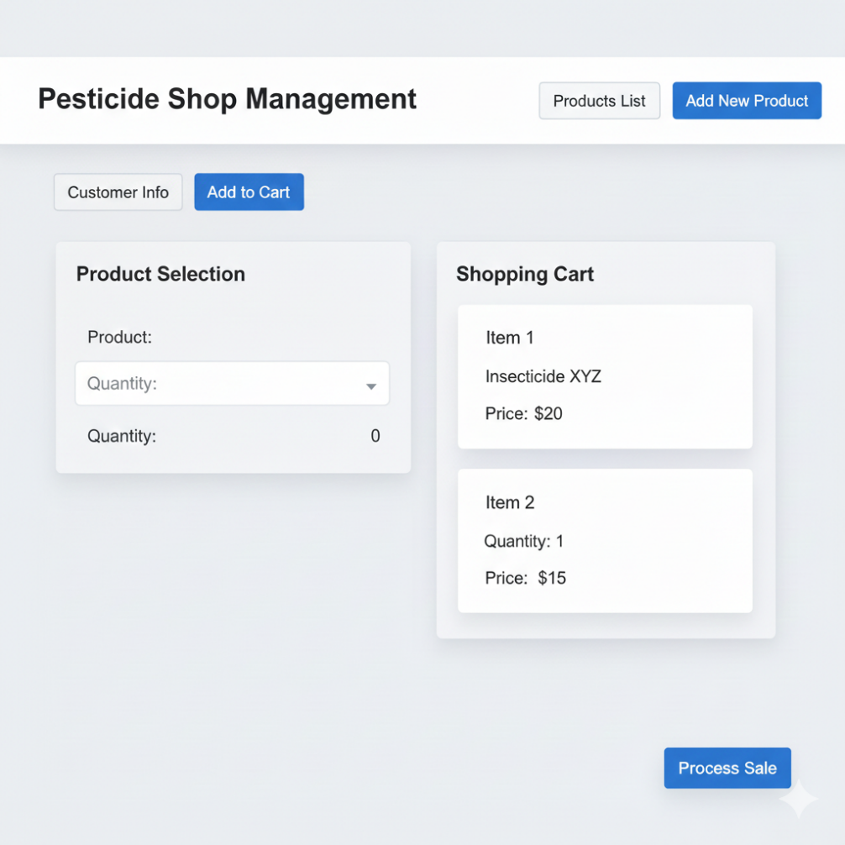
Figure: sales management
These are basic wireframes illustrating the layout and key elements of the Product Management and Sales screens. Depending on your system's features and requirements, you can further refine and expand these wireframes. Use a UI design tool to create more polished and detailed visuals based on these wireframes.
8. Security Considerations
Detailed security measures for protecting user data, managing access controls, and securing communications.
Ensuring the security of a pesticide shop management system is crucial to protect sensitive data, maintain the integrity of transactions, and safeguard the system from potential threats. Here are some key security considerations for such a system:
1. Authentication and Authorization:
- Implement strong authentication mechanisms to verify the identity of users. Consider multi-factor authentication for added security.
- Set up proper authorization controls to ensure that users have the necessary permissions to access specific functionalities or data.

2. Secure Communication:
- Use secure communication protocols (HTTPS) to encrypt data transmitted between the client and the server, preventing eavesdropping and man-in-the-middle attacks.
3. Data Encryption:
- Encrypt sensitive data at rest in the database to protect it in case of unauthorized access. Use strong encryption algorithms to secure stored information.
4.Input Validation:
- Implement thorough input validation to prevent common web vulnerabilities such as SQL injection, cross-site scripting (XSS), and cross-site request forgery (CSRF).
5. Session Management:
- Employ secure session management practices, including session timeouts, secure session storage, and the use of secure cookies. Invalidate sessions after logout.
6.Secure Password Handling:
- Store passwords securely using strong, adaptive hashing algorithms. Encourage users to create strong passwords and consider implementing password policies.
7. Audit Trails and Logging:
- Implement comprehensive logging mechanisms to record user activities, system events, and potential security incidents. Regularly review logs for suspicious activities.
8.Security Patching and Updates:
- Keep all software components, including the operating system, web server, database server, and third-party libraries, up to date with the latest security patches and updates.
9.Role-Based Access Control (RBAC):
- Implement RBAC to restrict access to system functionalities based on user roles. Regularly review and update role assignments as needed.
10. Secure File Uploads:
- If the system allows file uploads, implement proper validation and restrictions to prevent the upload of malicious files. Consider scanning uploaded files for malware.
11.Network Security:
- Configure firewalls to restrict unnecessary network traffic. Use intrusion detection and prevention systems to monitor and respond to suspicious activities.

12. Vendor and Third-Party Security:
- If the system relies on third-party services or components, ensure they follow security best practices. Regularly update and patch third-party libraries.
13. Data Backups and Recovery:
- Implement regular data backups and test the restoration process. Ensure backups are stored securely and are easily recoverable in case of data loss or a security incident.
14. Employee Training:
- Educate employees about security best practices, including password hygiene, social engineering awareness, and the importance of reporting security incidents promptly.
15. Privacy Compliance:
- Ensure compliance with relevant privacy regulations and standards. Protect customer information and provide transparent policies regarding data collection and usage.
16. Incident Response Plan:
- Develop and regularly test an incident response plan to quickly and effectively respond to security incidents, minimizing potential damage and downtime.
Regular security assessments, penetration testing, and continuous monitoring are essential to identify and address potential vulnerabilities in the pesticide shop management system. Security should be an ongoing consideration throughout the system's lifecycle.

9. Conclusion
This Software Design Document provides an extensive guide for developers to implement the Pesticide Management System. It outlines the technical architecture, design patterns, and technologies to be employed during the development phase.

